# Guide to Automation

## Step 01 – clone repo from <https://github.com/NuwanChaminda/SimpleBDDTest/tree/master>

## Step 02- Update the API token with yours

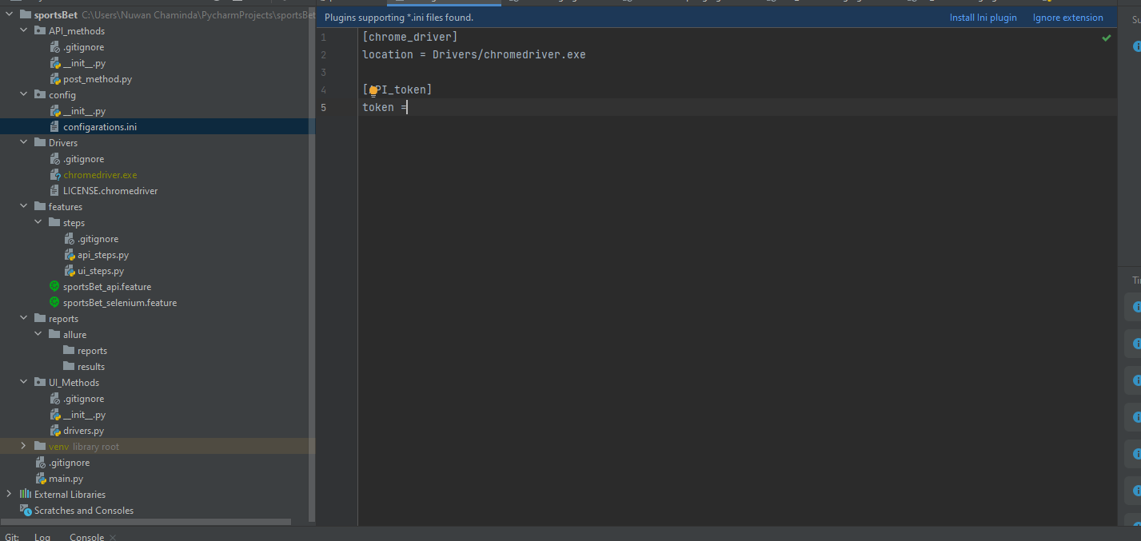

## Step 03 – Install libraries from libs.txt file using below command

pip install -r libs. Txt

## Step 04 – Check for JAVA installation and install allure npm library as mentioned in the below URL

<https://www.npmjs.com/package/allure-commandline>

## Step 05 – after each run delete results and reports on allure folder

